Radiative transfer effects in halites

Peter McCullough

2019 Sep 17

The transfer of sun light from the sky to the microorganisms inside halites is complicated. The solar spectrum is well known and readily predictable to good accuracy for any location on Earth, including the absorption of the Earth’s atmosphere. Measuring and modeling the intensity and spectrum of light at specific locations inside a halite nodule is a challenge we have addressed in this work.

To measure the light in the lab or in the field, we have used a handheld fiber optic spectrometer, controlled by a laptop computer. From the underside of the halite nodule, we drill a hole to a specific depth corresponding to a particular distance from the illuminated (top) surface of the halite nodule, then insert a fiber optic probe into the hole. By dividing the calibrated measurement of the spectrum inside a hole to that measured without the halite nodule in place, we determine an effective transmission spectrum for the halite at any particular depth. Using that effective transmission and our knowledge of the incident light from the sun, we know the spectral irradiance available to the microorganisms at specific locations inside the halite nodule. In this work, for comparison with the results from the molecular biology of samples scraped from inside the halite nodule near the top, middle, and bottom of halites, we likewise measured spectra near the top, middle, and bottom of halite nodules. We did not measure the same nodules by both techniques (molecular and optical), so our interpretation relies on the generic characteristics being similar from one halite to another, albeit with the recognition that variations in properties certainly occur.

Due to the practical difficulties of operating the spectrometer, the drill, etc in the desert environment, also with the solar illumination changing with time, our most trust worthy results were obtained in the lab. In the lab on April 10, 2018, we used a 500 W, stable, halogen lamp to illuminate the halites from 44 cm above, as a simulator of the solar illumination. Because we measure the lamp’s spectrum and normalize against it to obtain the effective transmission inside the halite, the lamp’s spectrum does not matter as long as it provides sufficient light to enable a good signal to noise ratio over the wavelength range of interest (here, from 500 nm to 900 nm). We used a cosine-corrector to homogenize the fiber optic cable’s angular response. The cosine corrector is a translucent circular screen that receives incident light, scatters it without affecting its spectrum, and transmits it to the fiber optic cable. The fiber optic cable always views a uniform scene; from source to source only the scene’s intensity and spectrum change. The irradiance inside the halite can be estimated as the solar irradiance incident upon the halite times the effective transmission from the surface in to the specific location within the halite.

We model the halite as an infinitely-wide slab; in this approximation only light incident upon the halite’s top surface can get inside, i.e. we neglect light that may enter from the sides or from underneath the halite through its bottom surface. This approximation is a good one inside the halite for positions near the top surface or even the middle of the halite, but becomes suspect far from the top surface. As the location becomes closer to the bottom surface of the halite than its top surface, the infinite-slab model fails: the fraction of light coming from the sides and underside of the halite become significant, even dominant, compared to meager light filtering through the halite from the top surface. For these reasons our attempts to measure the effective transmission deep within halites, i.e. far from their top surfaces and close to their bottom surfaces, have produced unreliable measurements in the lab with suspect applicability to actual halites in the desert.[1]

We can predict the effective transmission for light coming down from the top surface to the bottom position as follows. We assume the difference in relative transmission from the top position to the middle position is the same as the difference in relative transmission from the middle position to the bottom position. Equivalently, the appropriate curve for the effective transmission at the bottom position (dashed blue lines in the Figure) is such that each middle curve is halfway between the curves for the top position and the bottom position.

On the other hand, we can model the irradiance close to the bottom surface based upon our measurement of effective transmission near the top surface, combined with in situ measurement of halites in the natural environment. At Salar Grande North on March 25, 2019, we aimed the fiber probe with its cosine corrector downward into a typical region shaded underneath an overhang of a halite: at 600 nm, it was 0.7% that of the direct sunlight at midday in the same environment. Also, the spectrum was approximately solar, i.e. the ground’s reflection was approximately grey. Of course, the measured value varied from one shaded region to another, but 0.7% is a typical measured level that we will use in this analysis. We next approximate the effective transmission from the bottom of the halite inside to the bottom position of the fiber probe as equal to the effective transmission from the top of the halite inside to the top position of the fiber probe, which we measured in the lab. With those approximations, we can estimate the irradiance inside a halite 10 mm above its bottom surface as 0.007 times the irradiance inside the halite 10 mm below its top surface (cf. Figure’s blue solid lines).

The latter effect (light filtering up from below) will be even more significant for positions closer to the bottom surface of the halite than the 10 mm separation modeled here. Thus, inside any given halite, as we consider positions increasingly far from the top surface, the brightness of light filtering down from above relative to that filtering up from below will at some point (near the bottom of the halite) change from mostly coming from above to mostly coming from below.

Due to multiple scatterings, the optical conditions inside a halite experienced by a microorganism must be similar to that seen by a human in white-out conditions of snow or fog (the directionality of light is lost): the light incident upon either one is omnidirectional, i.e. isotropic.

Halites exhibit much heterogeneity, both within a given halite and from one halite to another. The main effects we have observed are pores in the salt substrate (related to deliquescence), and also dirt mixed with the salt substrate. The dirt pervades the salt in somewhat random 3-D structures, and it often nonuniformly coats the surface, especially the top surface (deposited by the wind). Such dirt absorbs light more than a translucent, pure salt substrate. The pores are elongated, approximately linear, shapes. As such, the pores can act like natural fiber-optic cables, transmitting light from one end of the pore (say, at the top surface) to the other end (e.g. deep within the halite), either by direct in-air transmission along the pore’s long axis, or by multiple reflections off the pore’s interior white surface of the salt substrate. In addition, pores often group together in parallel, with thin walls of salt between each, like a bundle of fiber optics, increasing the amount of light transmitted along them.

To simplify the Figure, we normalized the curves corresponding to the top positions such that curves B and C equal curve A at 720 nm: we divided curves B and C by scalars, 0.05 and 0.25, respectively. We did the same to the middle-position curves B and C.

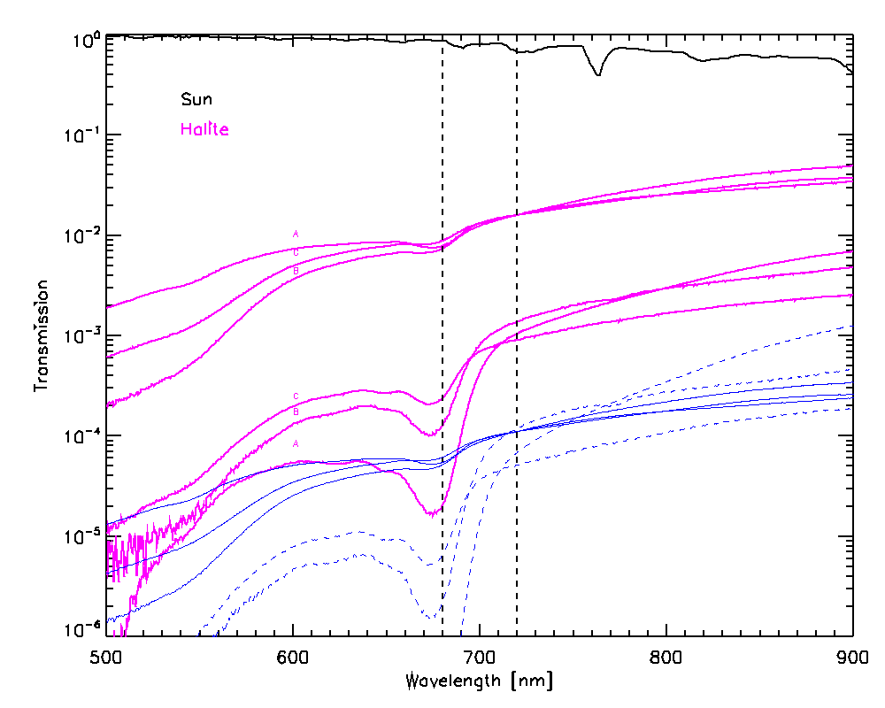

Figure caption:

The effective transmission for three halite replicates (A, B, and C) from the top surface to three interior positions (top, middle, bottom). Measured from top to bottom, the thicknesses of halites A, B, and C are 60 mm, 40 mm, and 77 mm, respectively. The top positions are 10 mm below the top surface (magenta solid lines near transmission=0.01 at 720 nm). The bottom positions are 10 mm above the bottom surface (dashed blue lines, modeled not measured, see text; lettering as middle). The middle positions are halfway between the top and bottom positions (magenta solid lines near transmission=0.001 at 720 nm). The spectra for the middle positions exhibit prominent chlorophyll A absorption around 680 nm. The solid blue lines are copies of the lines associated with the top positions multiplied by 0.007 (see text; lettering as top) to approximate the relative irradiance at the bottom positions due to light transmitted up from below originating from the shaded region underneath the halite in the field. That the solid blue lines are greater than the dashed blue lines (for the biologically significant wavelengths less than approximately 720 nm) illustrates the potential (at the bottom positions) for light filtering up from below to be brighter than light filtering down from above. The solar irradiance at the surface of the Earth, normalized to unity at its peak, is shown as a black solid line. Approximate absorption cross section peaks of chlorophyll a (680 nm) and chlorophyll f (720 nm) are indicated with vertical dashed lines.

To simplify the Figure, we normalized the curves corresponding to the top positions such that curves B and C equal curve A at 720 nm: we divided curves B and C by scalars, 0.05 and 0.25, respectively. We did the same to the middle-position curves B and C.

Add spect for the instrument to be found in the header of a spectrum

I recall that I used the 100 um slit width.

For example…

Data from ha04_a30L_FLMS070571_001.txt Node

Date: Tue Apr 10 14:05:12 EDT 2018

User: peter

Spectrometer: FLMS07057

Trigger mode: 0

Integration Time (sec): 1.000000E0

Scans to average: 9

Electric dark correction enabled: true

Nonlinearity correction enabled: false

Boxcar width: 0

XAxis mode: Wavelengths

Number of Pixels in Spectrum: 2048

>>>>>Begin Spectral Data<<<<<

1. If the issue was only one of signal to noise ratio, which does become a challenge deep within the halite, it could be overcome by using a brighter light source, a wider spectrometer slit, integrating longer, or averaging more spectra. However, none of those would help with the issues of light from the sides contaminating the measurement of light filtering from the top surface through the halite to the fiber optic probe.